Year 5 Learning
Date: 12th May 2020
Maths | WALT- multiply fractions by whole numbers  Follow the PowerPoint on the blog.  Questions:  Complete the mathletics activities set.  Extension:  This should be completed in the maths book given. Answers can be found at the bottom of the page.  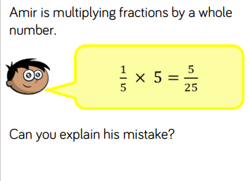
English | WALT- use short sentences to create suspense.  Hanny decides that the house is not safe for Mouse. Mouse’s mother asked her asked her to take care of him and she thinks the right thing to do is to take him away. Write a paragraph about her leaving. This would be a scary time- she doesn’t want to be caught! Use short sentences to create tension and suspense.
Reading | Readtheory.org x 10  Read your own book for 20 minutes
Spelling | Spellingframe.co.uk- spelling rule 58
Art | WALT- use point perspective to create depth.  https://www.youtube.com/watch?v=sZD8BjTK8dE  Watch the tutorial and create your own drawing using one point perspective. Take a look at these examples:  