Year 5 Learning
Date: 11th May 2020
Maths | WALT- subtract a fraction from a mixed number  Parents note: In order to do this lesson, children must be able to convert mixed numbers to improper fractions and vice versa. If this is challenge, spend more time on this instead. Use this link: https://whiterosemaths.com/homelearning/year-5/  Watch week 4 lesson 3 to support this.  For today’s lesson:  Follow the PowerPoint on the blog for a step by step guide. You can also watch this tutorial:  https://www.youtube.com/watch?v=zPOSnD02DQc  Questions:  Answers at the end of the page  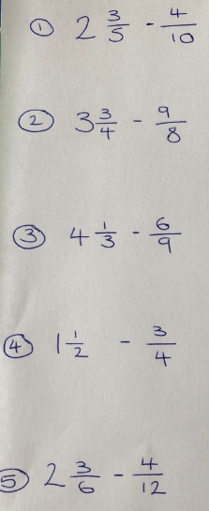
English | WALT- improve reading skills.  Complete the reading comprehension that can be found on today’s blog. The answers are also there.
Reading | Readtheroy.org x 10  Read your own book for 20 minutes
Spelling | Spellingframe.co.uk- Spelling rule 58
Geography | WALT- identify different types of settlement  Follow the lesson on bbc bitsize. Complete both activities.  https://www.bbc.co.uk/bitesize/articles/zh2nscw  Once you have completed the lesson, think about what type of settlement Potters Bar is.
Maths Answers | 