Day of the week | Amount of taxis | Number
Monday | 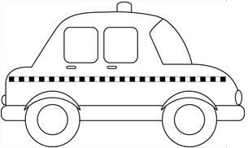
Tuesday
Wednesday
Thursday
Friday

Use the pictogram to answer these questions. Remember to read the questions carefully!

How many taxis were in the garage altogether?

……………………………………

How many more taxis were in the garage on Monday than on
Tuesday?

……………………………………

How many taxis were there altogether on Tuesday and Wednesday?

……………………………………

How many taxis were there altogether on Thursday and Wednesday?

……………………………………

How many more taxis were in the garage on Wednesday than on
Friday?
……………………………………

