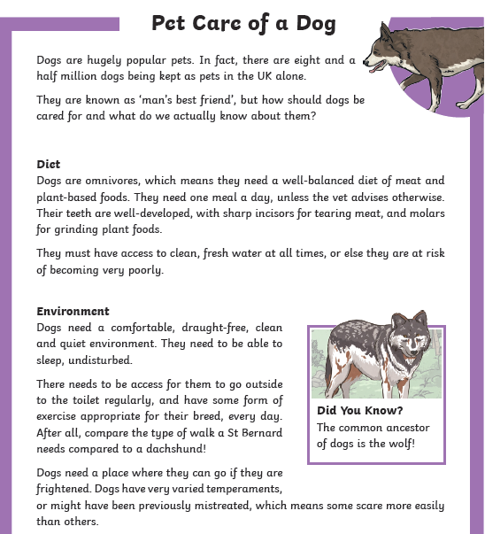
Pronouns have been boxed in black and subheadings in red.

