Year 5 Learning
Date: 3rd April 2020
Maths | Fluency Friday  On Fridays, we will complete a series of questions based on learning we have already done. If your child is having difficulty with the multiplication in question 1, here is a link to an online tutorial: https://www.youtube.com/watch?v=RVYwunbpMHA&t=118s  This was the last unit we covered and so has not had as much practise.  Questions:  - 23 x 96  - 4531 divided by 4. Express your remainder as a fraction  - 1.2 x 0.3 =  - What is the product of 7 and 8?  - Round 2.14 to the nearest whole number?  - 1.2 x 1000  - 251 x 62  - 2536 divided by 5. Give your remainder as a decimal.  - Write an equivalent fraction for one half  - 5.6 + 15.29=  - 229, 273 + 1000=  - 3 = 9  12 ?  - Write the improper fraction and mixed number for the picture.  - 45,000 – 253 =  - 0.98 + ____= 1  Extension:  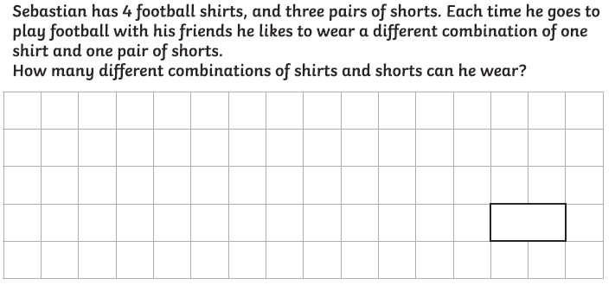
English | WALT- use SPaG knowledge  On Fridays, we will focus on SPaG. Answers are at the bottom of the page.  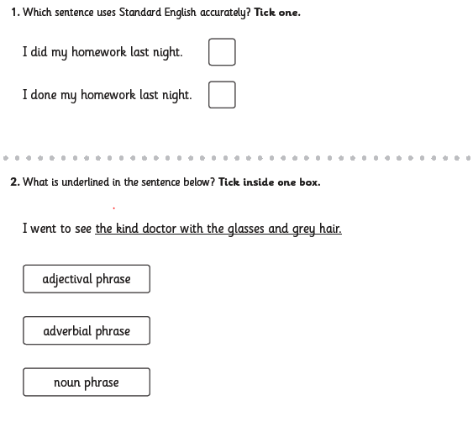  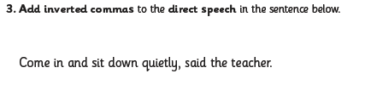  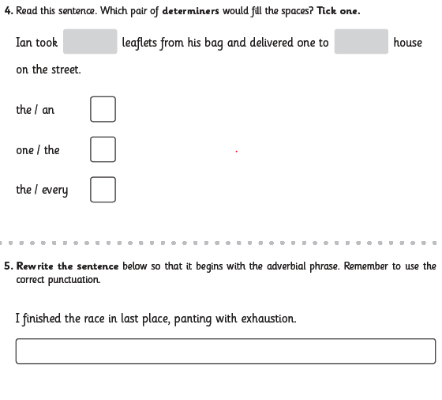  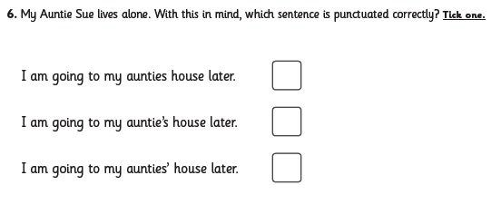  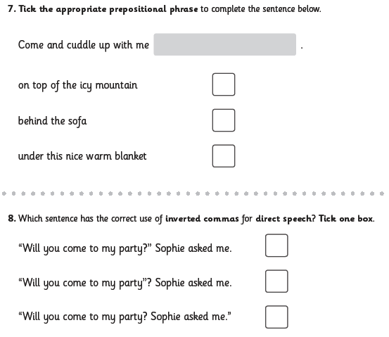  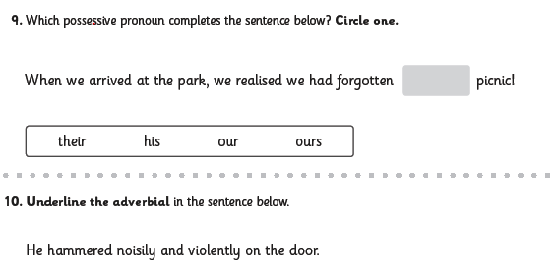
Reading | Readtheory.org x 10  Read your own book for 20 minutes
Spelling | Spellingframe.co.uk- take the spelling test for rule 54.
RE | WALT understand the actions and liturgy of Good Friday  Watch the clip:  www.youtube.com/watch?v=vO37DRIGgw0  In your books, answer the following questions:  - What is Good Friday?  - What do we remember about Jesus on this day?  - What actions did you see?  - What is the veneration?  - Why do Catholics do this?  - Why is there no Eucharistic celebration?  - Why is Good Friday important to Christians?  Make a cross. This could be out of card or any other material you have in your house. You could even go outside and make it out of sticks or stones. On Good Friday, we asked to consider the sacrifices we make. Write down some sacrifices you do, or could make for the greater good. Place them around the cross you have made. This could be on paper or leaves. Place them around the cross and take some time to quietly reflect on what you have written.

