Year 5 Learning
Date: 30th April 2020
Maths | WALT- add and subtract like fractions  Parents note: This is a consolidation of Year 4 fractions and so should be familiar for your child.  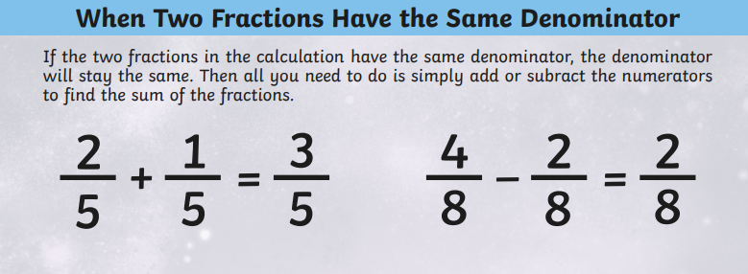  Questions:  complete the activities on mathletics  Extension:  This should be completed in the maths book given. Answers can be found at the bottom of the page.  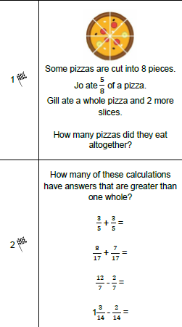
English | WALT- use figurative language.  You have put a lot of thought into Esther and her life. Use this to create poem about her and her life. Remember that it does not have to rhyme. Think about what writing tools you could use:  Repetition  Alliteration  Refrain (a repeated line between each verse)  Personification  Simile  Metaphor  Hyperbole
Reading | Readtheory.org x 10  Read your own book for 20 minutes
Spelling | Spellingframe.co.uk- continue with spelling rule 56
Science | WALT- compare the life cycles of different mammals.  Read the following information:  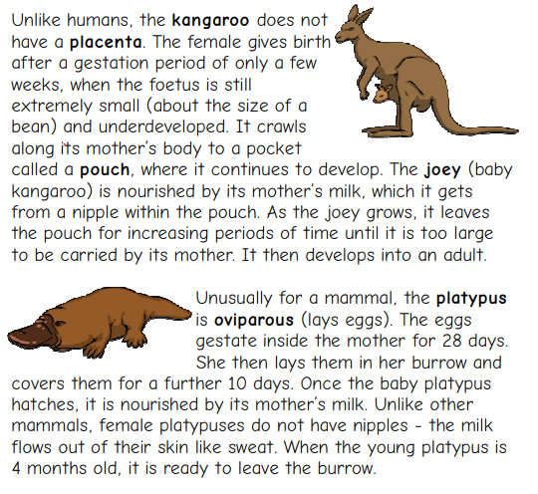  Draw and describe the life cycle of the mammals. Use the formats below:  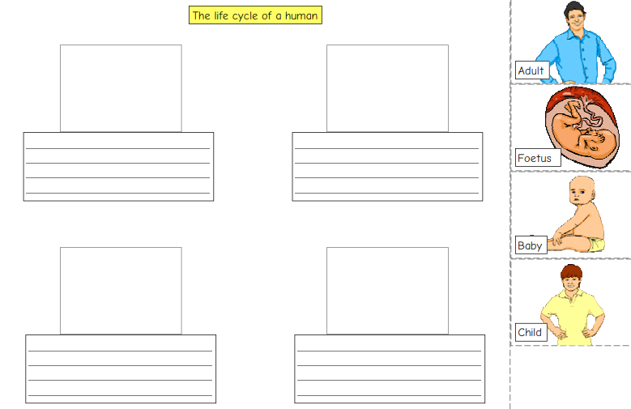  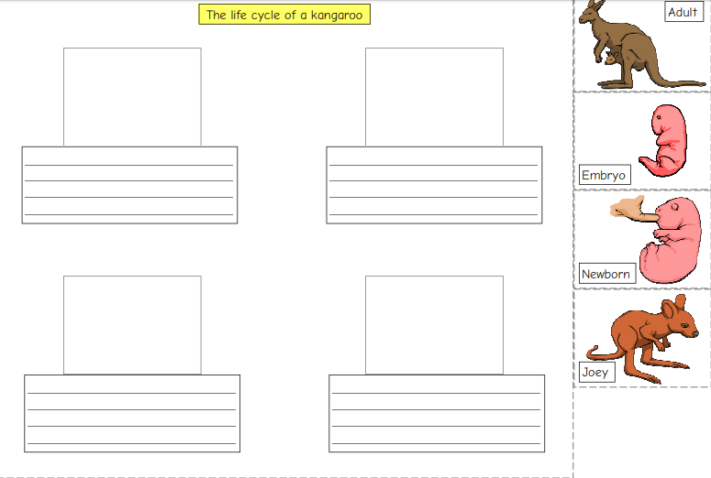  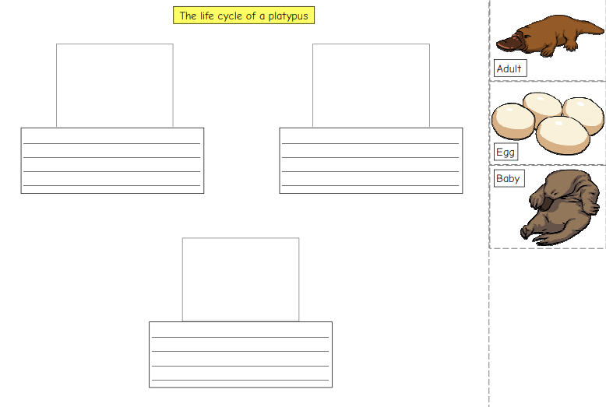  What do the life cycles have in common? How are they different?

