Year 5 Learning
Date: 2nd April 2020
Maths | WALT- understand improper fractions and mixed numbers.  Parents note: To begin with, we will be looking at the relationship between the two types of fraction through visual representations. We will move on to using calculating to convert them after the Easter break.  Watch the online tutorial:  https://www.youtube.com/watch?v=KEmCZGbd4R8  Questions:  Complete the tasks on mathletics  Extension:  This should be completed in the maths book given. Answers can be found at the bottom of the page.  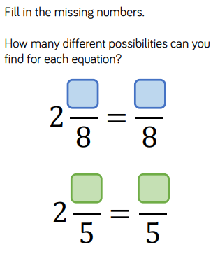
English | Now you have created your setting description of the campsite, you need to write the action sequence that follows. In order to do this effectively, you need to consider your verbs and sentence length. When we did our learning on the London Eye Mystery, we spoke about how short sentences create tension and suspense. We also learnt that these need to be mixed in between longer sentences otherwise it loses its effect and that we should only use a few.  Here is an example of an action sequence:  The boy gazed at the fire as he toasted marshmallows, oblivious to the creature which was slowly making its way up the path to the camp. With eyes glaring and teeth snarling, the creature rose upwards to a standing position behind the child perched by the fire. A twig snapped. Without hesitation, the young boy-scout whipped his head around and leapt from his seat, legs shaking. The marshmallow he had been toasting sat poised on the end of a stick and he thrust it towards the creature.  WALT- create an action sequence.
Reading | Readtheory.org x 10  Read your own book for 20 minutes
Spelling | Spellingframe.co.uk- continue with spelling rule 54
Music | WALT- listen and appreciate music  Listen to the following music and complete the questions below.  https://www.youtube.com/watch?v=NYvEvP2cmdk  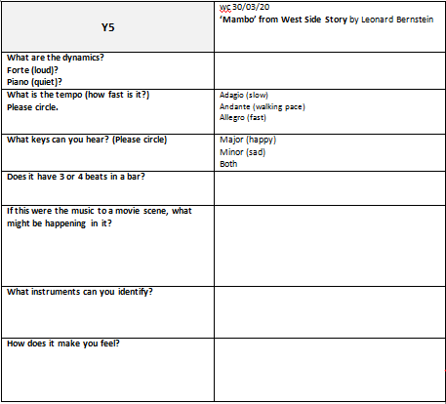
Science | WALT- compare the life cycles of different amphibians.  Read the following information:  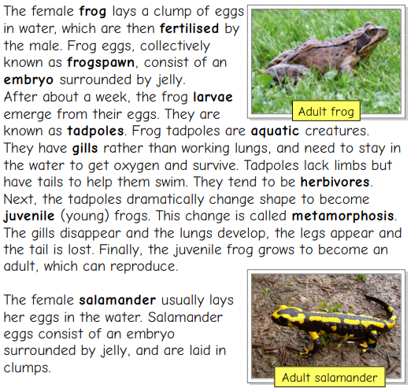  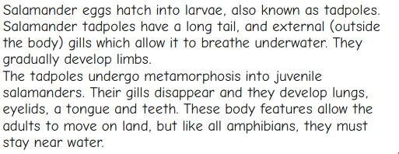  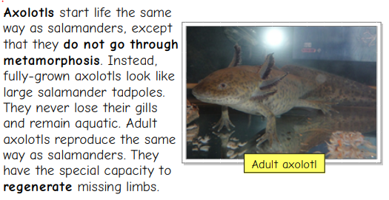  Draw and describe the life cycle of the amphibians. Use a format life below for each amphibian.  What do the life cycles have in common? How are they different?

