Year 5 Learning
Date: 29th April 2020
Maths | WALT- order fractions greater than 1.  Parents note: if your child is unsure of improper and mixed fractions, they will find this a challenge. If this is the case, instead of this task, take a look at tutorials from the week beginning the 20th April.  Use the maths powerpoint on the blog to guide you through this lesson.  Questions:  Extension:  This should be completed in the maths book given. Answers can be found at the bottom of the page.  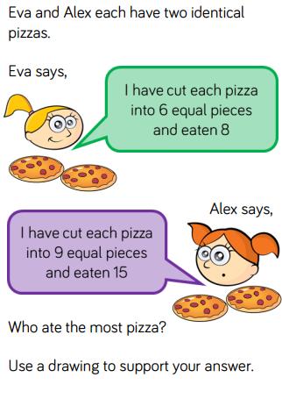
English | WALT- Edit and improve writing.  It is now time to edit your writing. Read your work about Esther as one continuous story. Remember that when we edit, we focus on one thing at a time.  For example:  First read through: punctuation  Second read through: tenses. Have you stayed in the present tense throughout and moved to past tense for the flashback? Have you then moved back into present tense to finish off?  Third read through: Looking for Year 5 content. Have you used relative clauses, parenthesis, modal verbs or adverbs of possibility.
Reading | Readtheory.org x 10  Read your own book for 20 minutes
Spelling | Spellingframe.co.uk spelling rule 56
French | Complete a task in our duolingo classroom.
Computing | Practice your coding.  Go to the scratch website and follow a tutorial or your choice.  https://scratch.mit.edu/ideas
