Year 5 Learning
Date: 27th April 2020
Maths | WALT- order fractions  Watch the online tutorial:  https://www.youtube.com/watch?v=bj5fSn96Cns&t=43s  Questions:  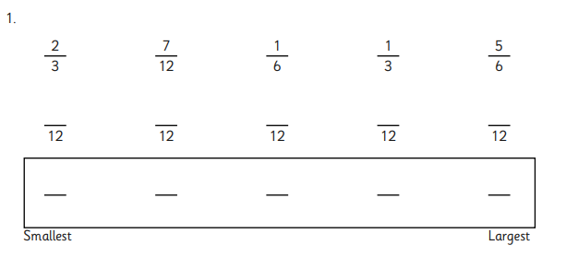  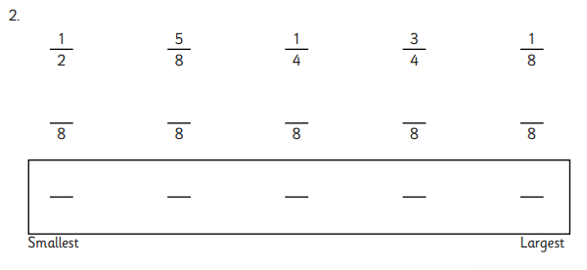  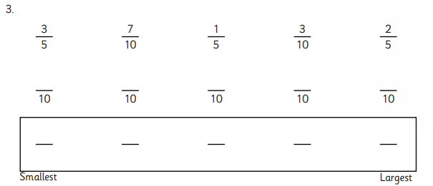  Extension:  This should be completed in the maths book given. Answer at the bottom of the page.  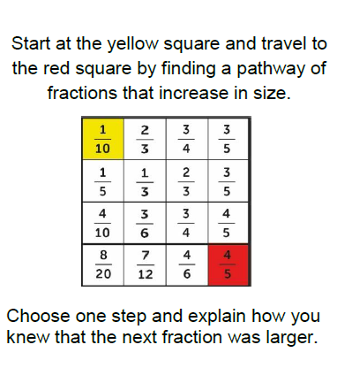
English | On Thursday, you thought about ways that Esther’s life could change. Chose one of these to write. Remember, we have been writing in the present tense.  Today you should include two hyperboles. A hyperbole is an obvious exaggeration that is not meant to be taken literally. For example:  My tent is lost in a sea of millions of cars and I wade through mud up to my armpits to clamber towards the ragged cloth which serves as a door.  WALT- use hyperbole.
Reading | Readtheroy.org x 10  Read your own book for 20 minutes
Spelling | Spellingframe.co.uk Spelling rule 55
History | Continue with your project about what life is like at this time from last week.

