Year 5 Learning
Date: 24th April 2020
Maths | Fluency Friday  On Fridays, we will complete a series of questions based on learning we have already done. If your child is having difficulty with the multiplication in question 1, here is a link to an online tutorial: https://www.youtube.com/watch?v=RVYwunbpMHA&t=118s  This was the last unit we covered and so has not had as much practise.  Questions:  - 142 x 23  - 2540 divided by 4  - 0.7 x 0.04  - What is the product of 4 and 8?  - Round 7.93 to the nearest tenth?  - 6342 divided by 3  - 0.72+ ____= 1  - What is 26 as a mixed number?  4  - 1340 divided by 100  - 4871 divided by 4. Express the remainder as a fraction.  - Write 276, 028 in words.  - Write an equivalent fraction of a half.  - 5 = 15  12  - What is 7 6 as an improper fraction?  8  - 92.202 – 5.82 =  Extension:  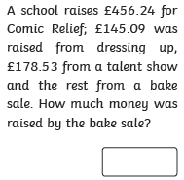
English | WALT- use SPaG knowledge  On Fridays, we will focus on SPaG. Answers are at the bottom of the page.  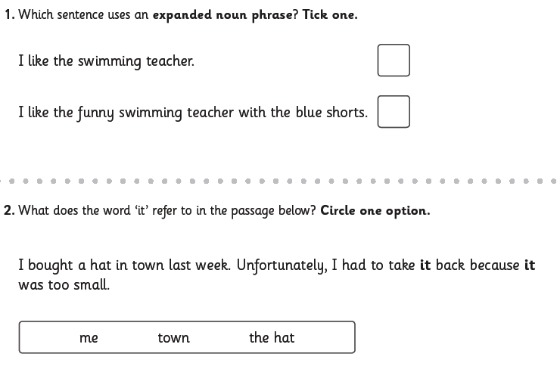  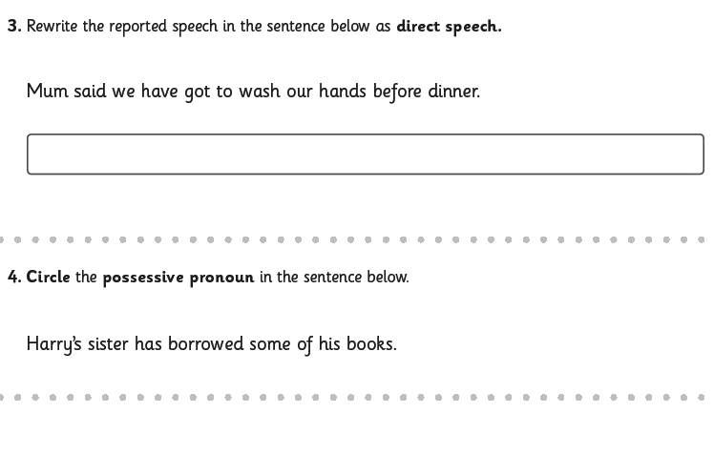  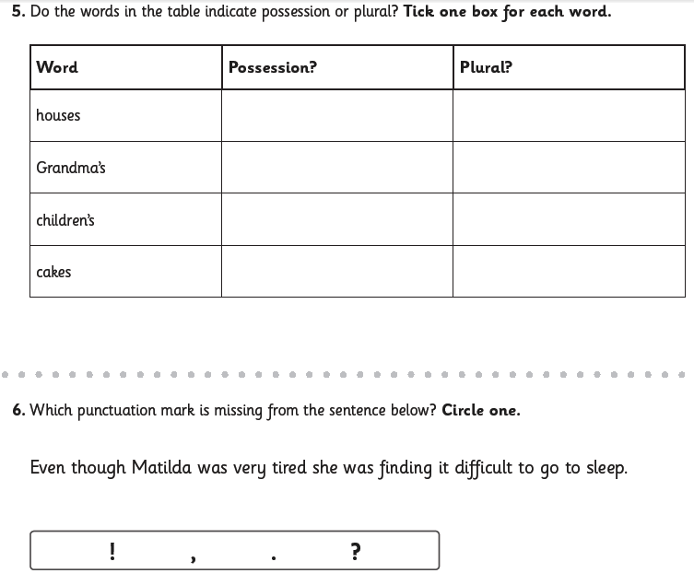  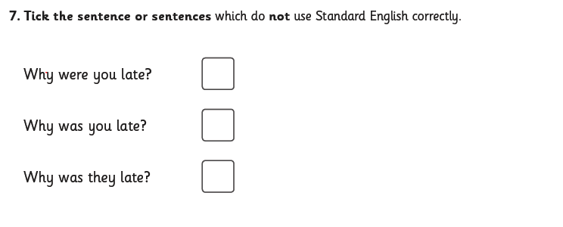  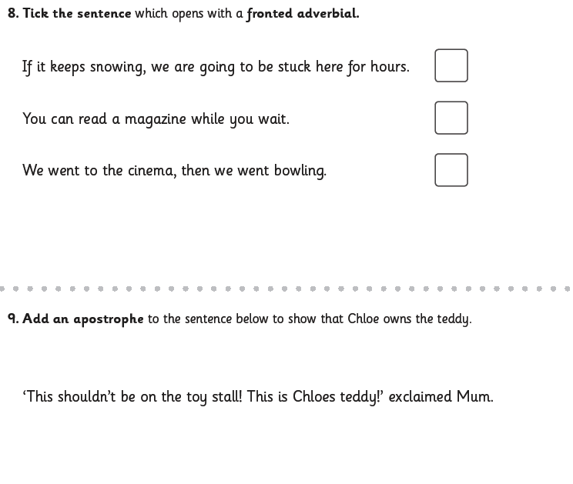  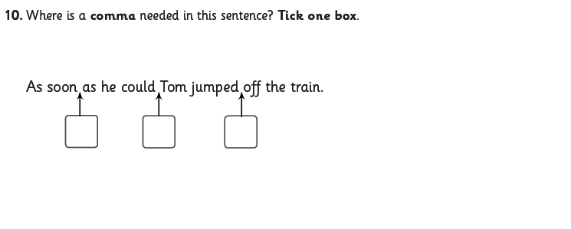
Reading | Readtheory.org x 10  Read your own book for 20 minutes
Spelling | Spellingframe.co.uk- take the spelling test for rule 55.
RE | WALT- Discuss artistic interpretations of the Resurrection.  Read Matthew’s account of the resurrection.  Matthew 28:1-10 Good News Translation (GNT)  The Resurrection  28 After the Sabbath, as Sunday morning was dawning, Mary Magdalene and the other Mary went to look at the tomb. ² Suddenly there was a violent earthquake; an angel of the Lord came down from heaven, rolled the stone away, and sat on it. ³ His appearance was like lightning, and his clothes were white as snow. ⁴ The guards were so afraid that they trembled and became like dead men.  ⁵ The angel spoke to the women. “You must not be afraid,” he said. “I know you are looking for Jesus, who was crucified. ⁶ He is not here; he has been raised, just as he said. Come here and see the place where he was lying. ⁷ Go quickly now, and tell his disciples, ‘He has been raised from death, and now he is going to Galilee ahead of you; there you will see him!’ Remember what I have told you.”  ⁸ So they left the tomb in a hurry, afraid and yet filled with joy, and ran to tell his disciples.  ⁹ Suddenly Jesus met them and said, “Peace be with you.” They came up to him, took hold of his feet, and worshiped him. ¹⁰ “Do not be afraid,” Jesus said to them. “Go and tell my brothers to go to Galilee, and there they will see me.”  Look at these pieces of art. For each one, answer the following questions:  - What can you see?  - What do you like/dislike about the painting?  - What colours/shapes can you see?  - What title would you give this painting?  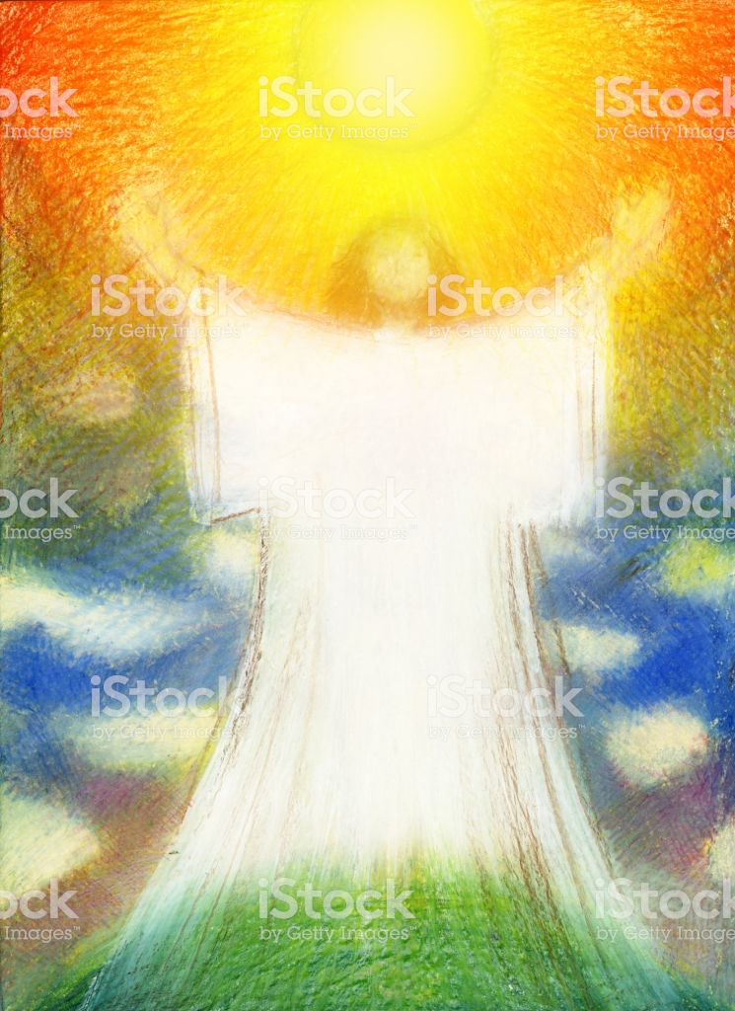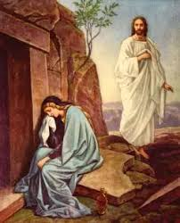  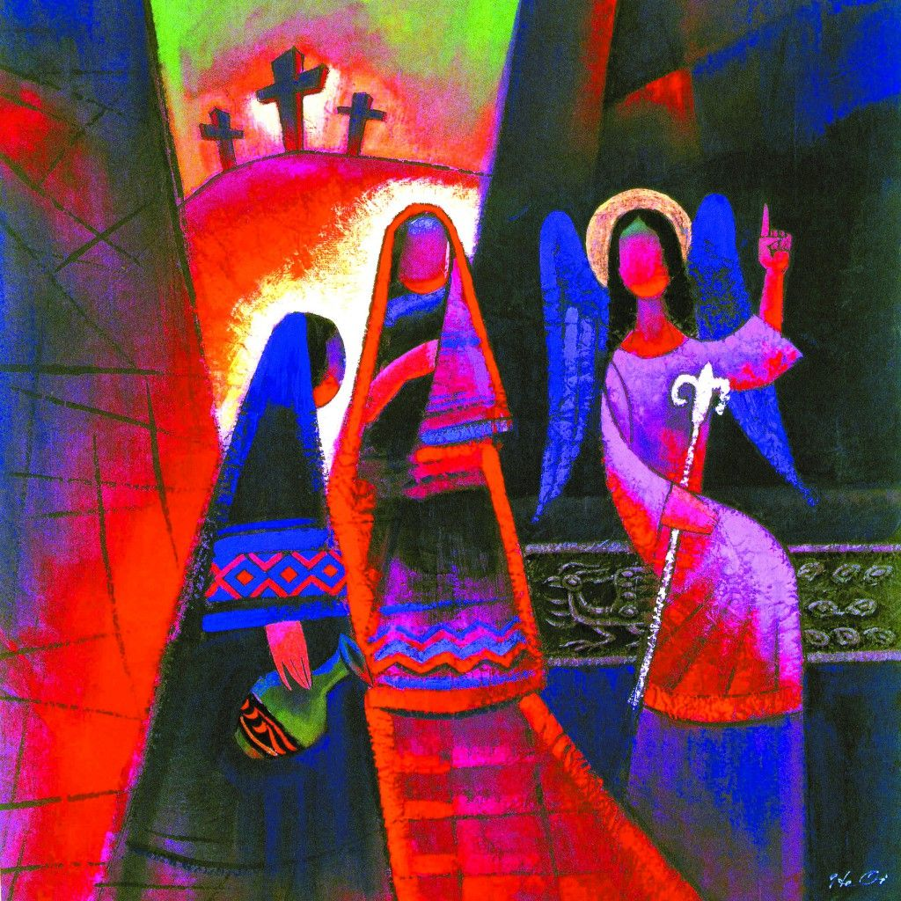  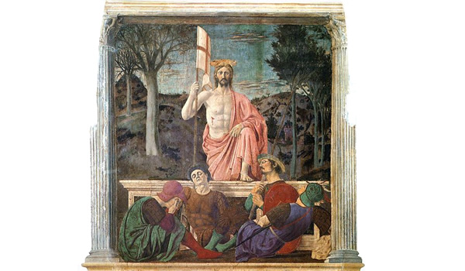  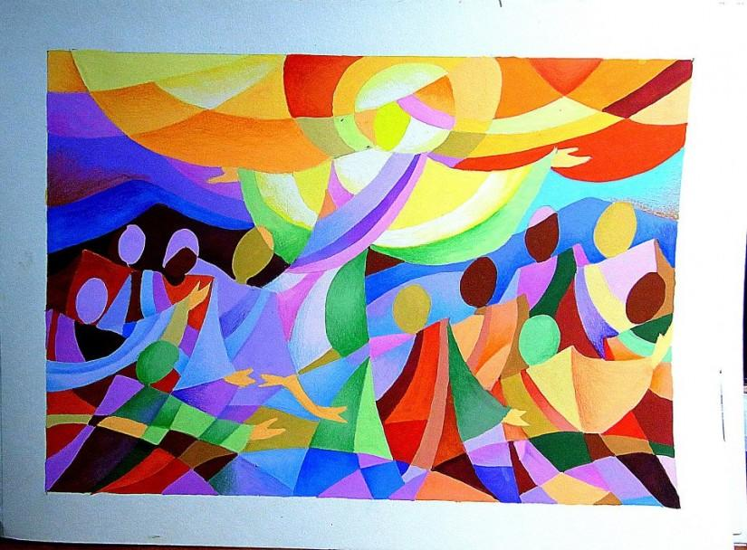  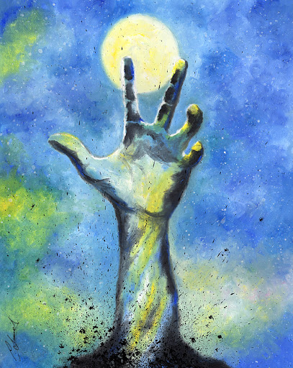  Which one to do like the best and why?  Which one would Matthew like the best and why?

