Year 5 Learning
Date: 23rd April 2020
Maths | WALT- compare fractions  Watch this online tutorial:  https://www.youtube.com/watch?v=nH7s9SIjwus  Questions:  complete the activities on mathletics  Extension:  This should be completed in the maths book given. Answers can be found at the bottom of the page.  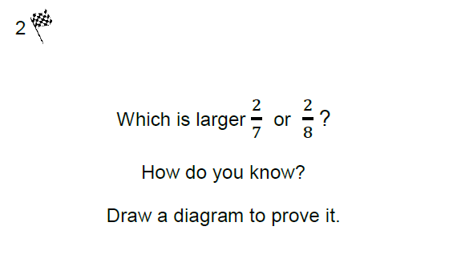
English | Just as you have written about Esther’s past, today you are going to think about her future. One day Esther’s fortunes change. Something happens that changes her life again from how it is currently. What could happen? Would it improve her life or make it worse?  Create 3 different predictions about what could happen to Esther. Summarise each one. Include how the change happens, what the change is and the effect on Esther.  WALT- make predictions based on a story.
Reading | Readtheory.org x 10  Read your own book for 20 minutes
Spelling | Spellingframe.co.uk- continue with spelling rule 55
Music | WALT- sing with feeling  Complete the bbc bitesize lesson by clicking the link below. Complete activity 1 and 2.  https://www.bbc.co.uk/bitesize/articles/z44x6v4
Science | WALT- compare the life cycles of different insects.  Read the following information:  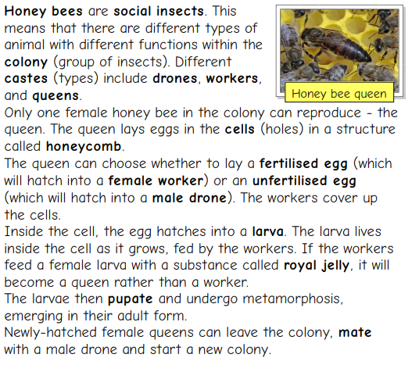  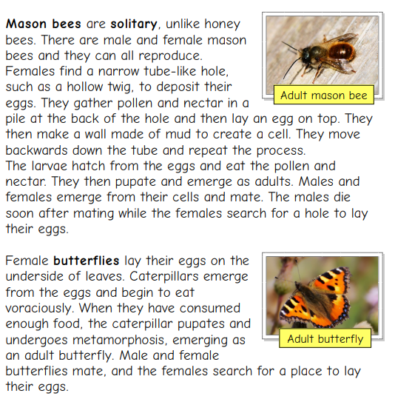  Draw and describe the life cycle of the insects. Use the formats below:  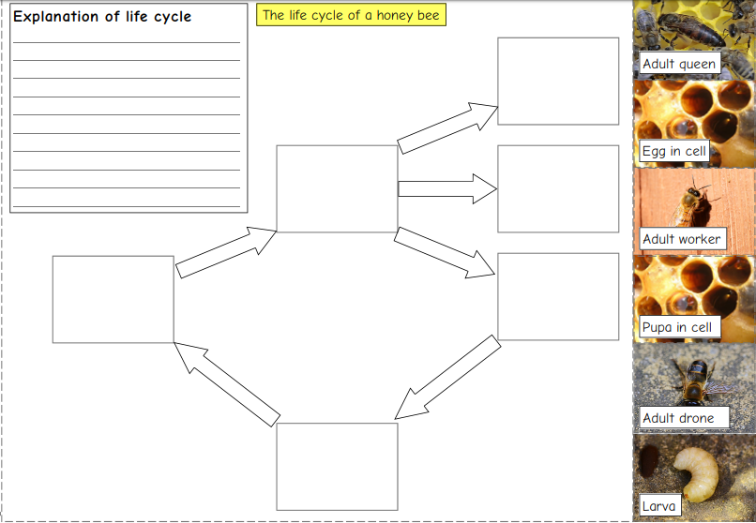  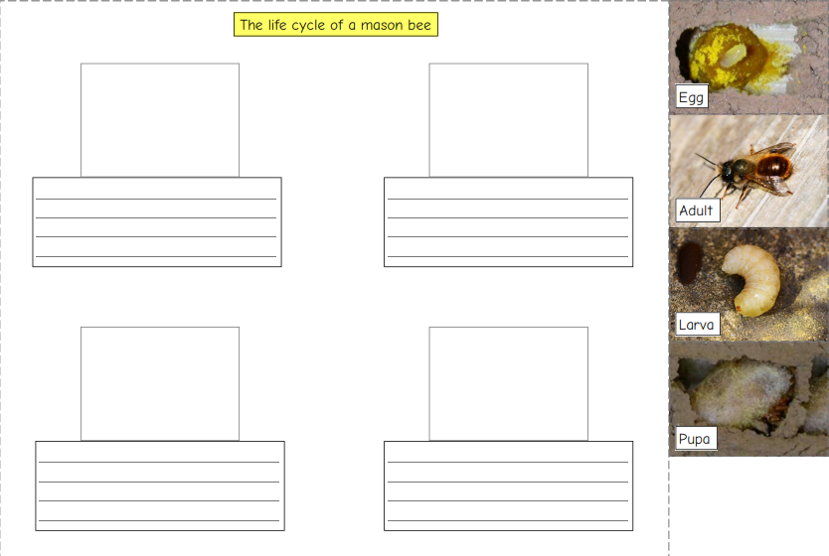  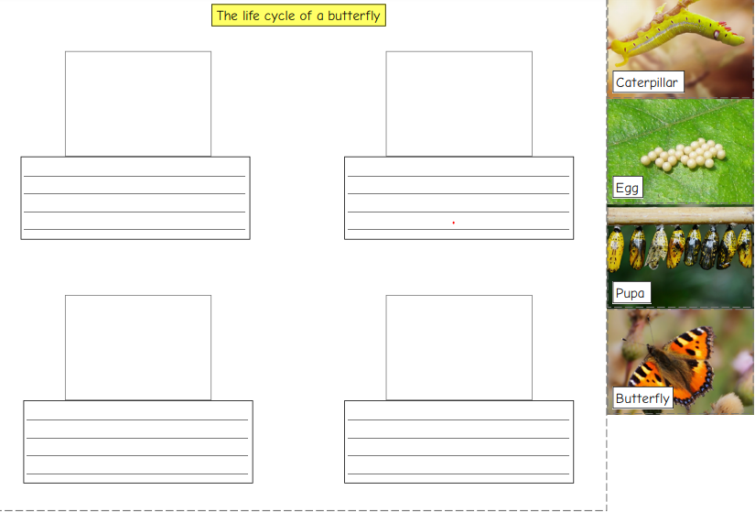  What do the life cycles have in common? How are they different?

