Year 5 Learning
Date: 22nd April 2020
Maths | WALT- apply knowledge of missed and improper fractions.  Parents note: If your child is still consolidating their learning of converting between mixed and improper fractions, please just complete the first set of questions. If they are confident, they can complete the problem solving.  Consolidating questions:  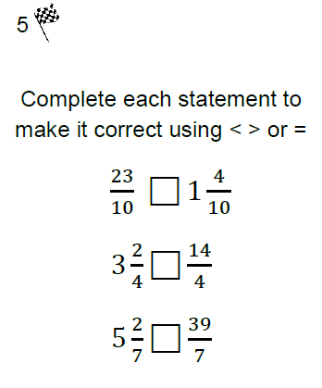  Questions:  - Sid works ¼ km away from home. If he walks to and from work each day, what is the total distance he walks in a school week? Write your answer as an improper fraction and a mixed number. Can you record your answer another way?  - Cakes are cut into six equal pieces to sell in a bakery. There are 19 slices of cake left at the end of the day. How many complete cakes are there?  - Eight pizza slices make one whole pizza. If 3½ pizzas have been eaten, how many slices is that?  - Children made 16½ litres of fruit punch to sell in ¼ litre cups. They had 21/4 litres left at the end of the fair. How many cups did they sell?  Extension:  This should be completed in the maths book given. Answers can be found at the bottom of the page.  Is it sometimes, always or never true that:  a) if the numerator of a fraction is larger than the denominator, then the fraction is bigger than 1 but smaller than 2?  b) a mixed number includes a fraction?
English | We continue with the story about Esther and her treasure.  Consider how Esther ended up here. What was her life like before? Was she happy then and is she happy now? Write a section explaining how her life changed. You must create clear cohesion to show what is in the past and what is in the present. Do this by using the word bank.  Start with the sentence: I didn’t always live here.  WALT- link the past and the present  Word bank:  Now  Today  Currently  In this day and age  Whereas, when I was younger  To begin with  At the present time  Many winters ago  In the past  Only back then  Previously  In days gone by  Back when
Reading | Readtheory.org x 10  Read your own book for 20 minutes
Spelling | Spellingframe.co.uk spelling rule 55
French | Complete a task in our duolingo classroom.
Computing | Learn to type; it is a great skill to have. In order to do this activity, you must have a keypad.  https://www.bbc.co.uk/bitesize/topics/zf2f9j6/articles/z3c6tfr  If you do not, please complete a scratch task.  https://scratch.mit.edu/ideas
- This is sometimes true but there is no limit on what the numerator can be. Therefore, it could be much larger than 2.
- This is always true as otherwise it is not a mixed number, it is a whole number.

