Year 5 Learning
Date: 20th April 2020
Maths | WALT- convert improper fractions to mixed numbers.  Parents note: It may be a good idea to refresh your child’s memory on improper fractions and mixed numbers by re-watching the clip from before the break: https://www.youtube.com/watch?v=KEmCZGbd4R8  Today we will use calculations to convert improper factions to mixed numbers.  Watch the online tutorial:  https://www.youtube.com/watch?v=GpumUOiGS6Q  Questions:  Complete the tasks on mathletics  Extension:  This should be completed in the maths book given. Children can use a calculator to check their answers.  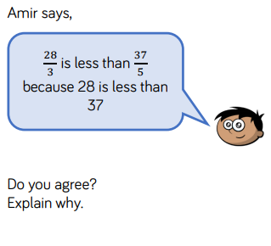  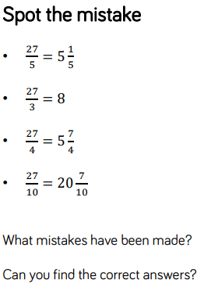
English | Watch the animation:  https://vimeo.com/24500500  It is about a woman called Esther. You are going to write in role as her today (first person) to describe yourself. You must imagine the person reading this has not seen the clip and so you need to give as much detail as possible. Do not overuse adjectives for the description. Consider other ways you can add more detail. For example, ‘my glasses are broken’ could include what the glasses are like, where they are broken and their position on her face: ‘The tarnished frames of my glasses are taped together at the corner, balancing precariously on the bridge of my nose.’  Remember that you are Esther and this should be written in the present tense. Through this writing, can you develop a sense of characterisation? For example, she might reference her younger self and include her personal thoughts and opinions on things. You need to get into her mindset and imagine what sort of character she might be. Is she funny, quirky, lonely or angry? This would all come across in her description of herself through the language she uses. Do not go too much into her past- we will get to that later!  You should start your writing with ‘As I look into the mirror’  WALT- write an effective character description in first person narrative.  Word bank  Broken Lonely Cracked Timid Worn Vulnerable Dishevelled Curious Aged Inquisitive Wrinkled Imaginative Haggard Settled Tired Resourceful Weary Contented Filthy Hopeful Odour Strong Numb Isolated Shivery Anxious Wispy Unfortunate Tattered Scrappy Gentle Humble Repaired Reflective.
Reading | Readtheroy.org x 10  Read your own book for 20 minutes
Spelling | Spellingframe.co.uk Spelling rule 55
RE | A Celebration of Easter  Here are a couple of activities to celebrate Easter. I have included some examples of each to give you some ideas.  Write a Resurrection Poem about what Easter means to you.  Think about what has happened and what this means for us all.  How does this time of year make you feel?  Think about how we celebrate and the events that usually happen.  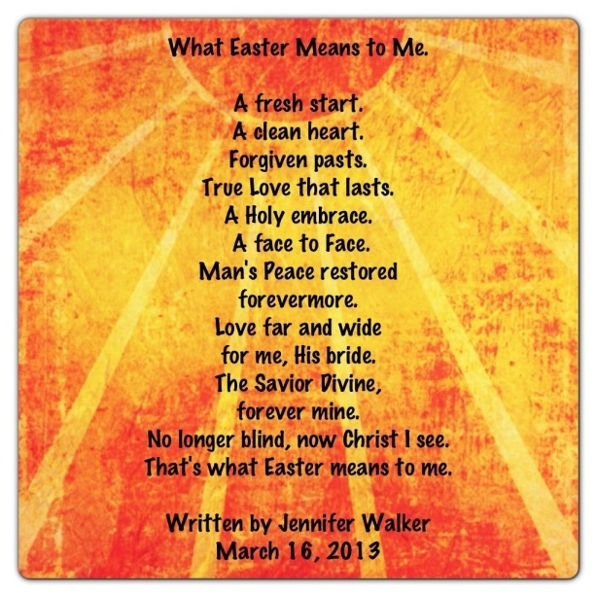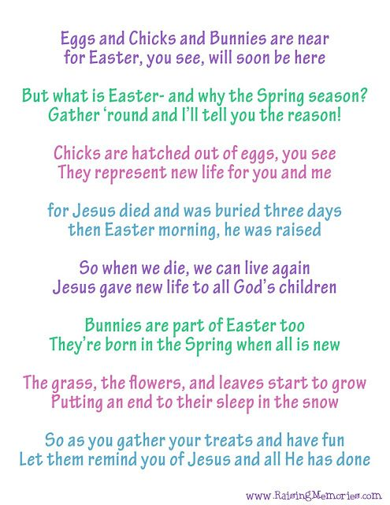  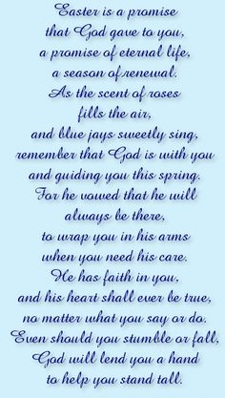  Create a piece of art about new life. This could be a drawing or making something with recycled materials. Symbols of new life include butterflies, flowers, shells and eggs.  