Year 5 Learning
Date: 1st May 2020
Maths | Fluency Friday  On Fridays, we will complete a series of questions based on learning we have already done. If your child is having difficulty with the multiplication in question 1, here is a link to an online tutorial: https://www.youtube.com/watch?v=RVYwunbpMHA&t=118s  This was the last unit we covered and so has not had as much practise.  Questions:  - 356 x 62  - 8760 divided by 6  - 0.05 x 0.06  - What is the product of 12 and 7?  - Round 15.27 to the nearest tenth.  - 2735 divided by 4 express the remainder as a decimal  - What is 38 as a mixed number?  3  - 14,298 divided by 1000  - 2547 divided by 8. Express the remainder as a fraction.  - Order from largest to smallest  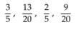  - Which is larger?  - Write the mixed number and improper fraction for this image:  - 8 = 2  12  - What is 9 4 as an improper fraction?  5  15. write 273,302 in words.  Extension:  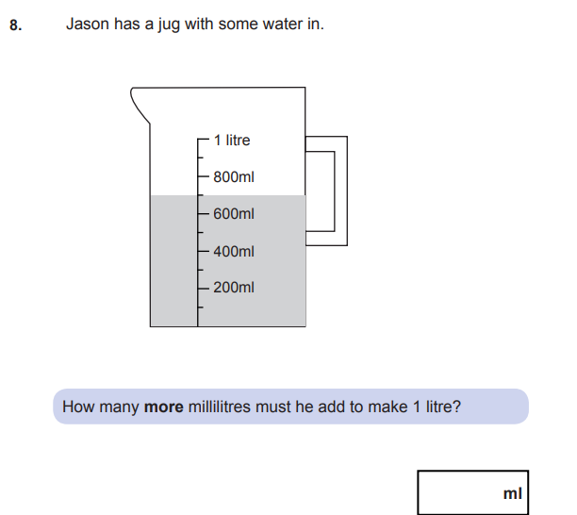
English | WALT- use SPaG knowledge  On Fridays, we will focus on SPaG. Answers are at the bottom of the page.  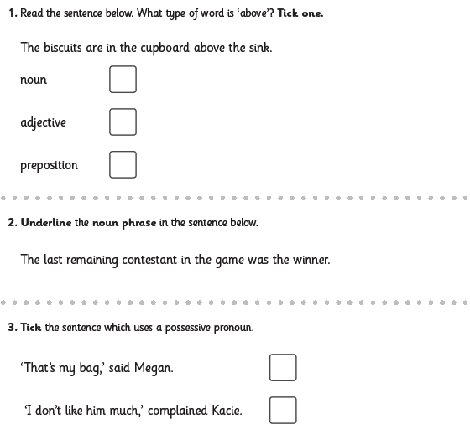  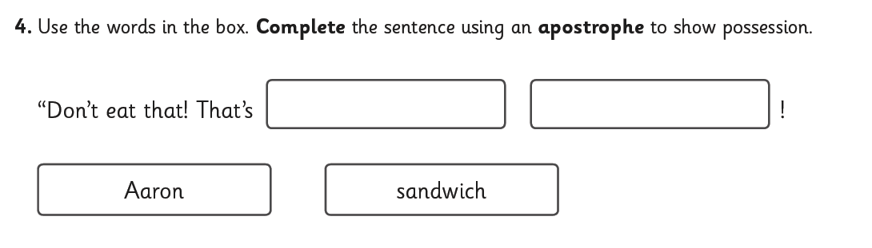  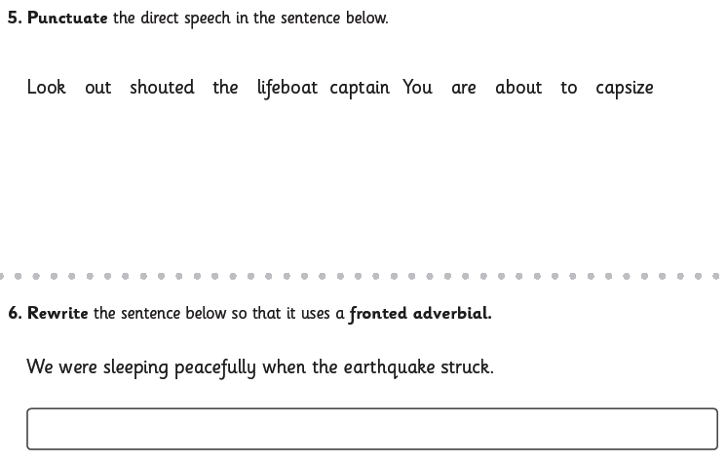  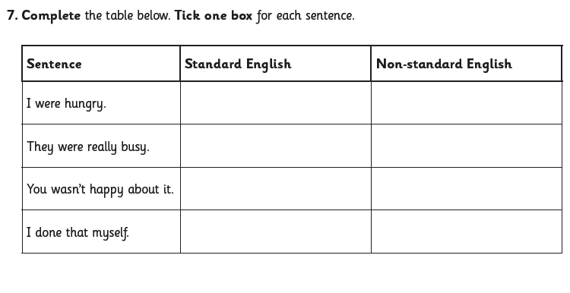  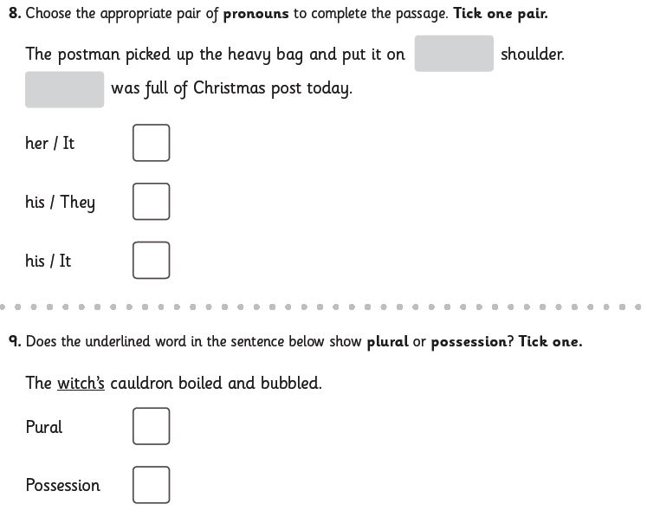  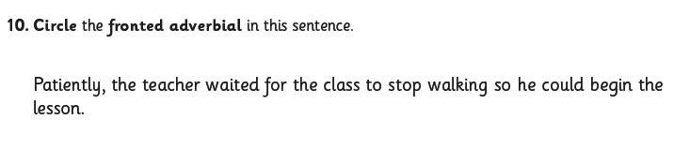
Reading | Readtheory.org x 10  Read your own book for 20 minutes
Spelling | Spellingframe.co.uk- take the spelling test for rule 56.
RE | WALT- compare how different Gospels record the Resurrection.  Read Matthew’s account of the resurrection.  Matthew 28:1-10 Good News Translation (GNT)  The Resurrection  28 After the Sabbath, as Sunday morning was dawning, Mary Magdalene and the other Mary went to look at the tomb. ² Suddenly there was a violent earthquake; an angel of the Lord came down from heaven, rolled the stone away, and sat on it. ³ His appearance was like lightning, and his clothes were white as snow. ⁴ The guards were so afraid that they trembled and became like dead men.  ⁵ The angel spoke to the women. “You must not be afraid,” he said. “I know you are looking for Jesus, who was crucified. ⁶ He is not here; he has been raised, just as he said. Come here and see the place where he was lying. ⁷ Go quickly now, and tell his disciples, ‘He has been raised from death, and now he is going to Galilee ahead of you; there you will see him!’ Remember what I have told you.”  ⁸ So they left the tomb in a hurry, afraid and yet filled with joy, and ran to tell his disciples.  ⁹ Suddenly Jesus met them and said, “Peace be with you.” They came up to him, took hold of his feet, and worshiped him. ¹⁰ “Do not be afraid,” Jesus said to them. “Go and tell my brothers to go to Galilee, and there they will see me.”  Now read Luke’s  Luke 24 New International Version (NIV)  Jesus Has Risen  24 On the first day of the week, very early in the morning, the women took the spices they had prepared and went to the tomb. ² They found the stone rolled away from the tomb, ³ but when they entered, they did not find the body of the Lord Jesus. ⁴ While they were wondering about this, suddenly two men in clothes that gleamed like lightning stood beside them. ⁵ In their fright the women bowed down with their faces to the ground, but the men said to them, “Why do you look for the living among the dead? ⁶ He is not here; he has risen! Remember how he told you, while he was still with you in Galilee: ⁷ ‘The Son of Man must be delivered over to the hands of sinners, be crucified and on the third day be raised again.’ ” ⁸ Then they remembered his words.  ⁹ When they came back from the tomb, they told all these things to the Eleven and to all the others. ¹⁰ It was Mary Magdalene, Joanna, Mary the mother of James, and the others with them who told this to the apostles. ¹¹ But they did not believe the women, because their words seemed to them like nonsense. ¹² Peter, however, got up and ran to the tomb. Bending over, he saw the strips of linen lying by themselves, and he went away, wondering to himself what had happened.  Questions:  In what way are they different?  In what way are they the same?  What is the belief expressed through both Gospels?  Which do you prefer and why?

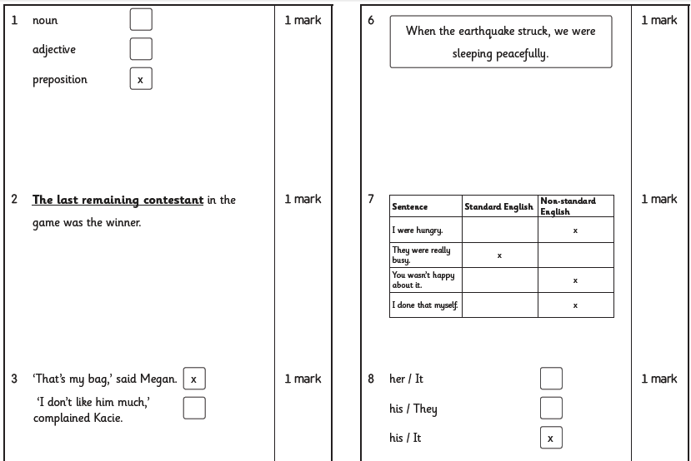
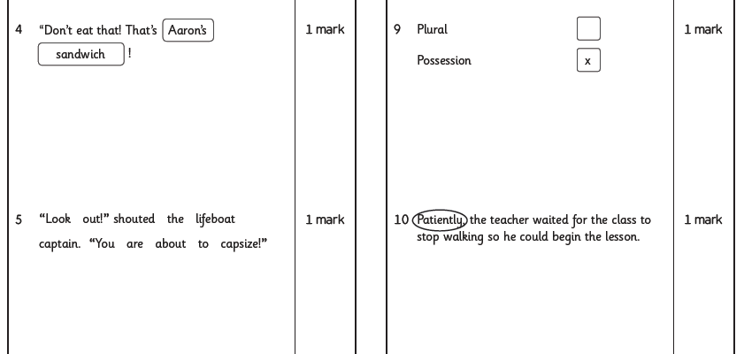

Maths answer- 300ml

