Year 5 Learning
Date: 30th March 2020
Maths | WALT-express remainders as decimals.  Parents note: We are back to division. As I have said before, this is a unit that Year 5 often find tricky, so please feel free to teach it at your child’s level. The key is to be able to complete short division, so if expressing remainders in different ways is too much, that’s fine. Just express the remainder as a remainder. For a refresher on short division: https://www.youtube.com/watch?v=lxg2eoNzFlA  On Thursday, we looked at turning a remainder into a fraction. If you understood that, it is time to express the remainder as a decimal.  Watch the online tutorial:  https://www.youtube.com/watch?v=gmNie3s4hcI  Questions:  Extension:  This should be completed in the maths book given. Children can use a calculator to check their answers.  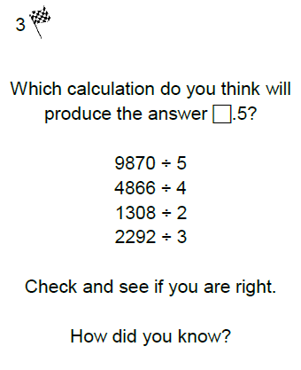  Hint- think about your rules of divisibility!  Fancy an extra challenge?  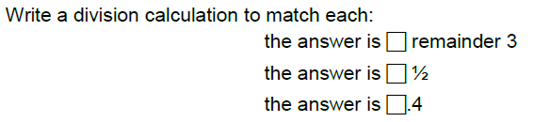
English | Story starter!  As the cogs began to turn once again, a flicker of light sparked from within.  Watching, waiting, anticipating its first move, the rise of the machine was imminent…  Sentence challenge!  A parenthesis is a word or a phrase put into a sentence to give it more information.  Sometimes a parenthesis is in brackets, sometimes there is a dash and sometimes it has commas around it.  Parentheses are used to:  Explain what a difficult word means.  Show someone’s thoughts  To add extra information to help the reader and/or emphasise a point.  Continue this story, using parenthesis. You don’t need to write a whole story, just a section. You could use your suspense skills from our London Eye Mystery learning to leave it on a cliff-hanger. Aim for 3 parenthesis.  Things to consider:  What is this machine? Is it good or evil? Who is it fighting/saving? What has happened that has led to this point?  Parents note:  We have already learnt about parenthesis and so your child should be familiar with the concept. It now needs to become a more natural part of your child’s writing in year 5.  WALT- use parenthesis
Reading | Readtheroy.org x 10  Read your own book for 20 minutes
Spelling | Spellingframe.co.uk- Spelling rule 54
Science | What if?  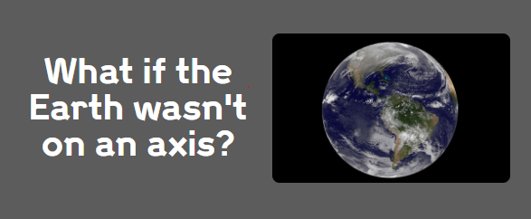  Use you scientific knowledge about the axis to explain what would happen if this were the case. What would happen? How would this affect you? Would be good or bad for anyone in particular?  WALT- reason scientifically
Geography | In year 5, we learnt a lot about the rainforest biome. Find out about one of the other major world biomes: tundra, desert or grassland.  Once you have selected the biome you want to find out about, create a fact file about it. Include the following information:  - Where in the world would you find it? Why is this?  - What animals live there?  - What plants can be found there?  - What people can be found there?  For each section, consider why and how that particular life is able to survive and thrive there.  WALT- identify and describe a world biome.

