Year 5 Learning
Date: 26th March 2020
Maths | WALT- express remainders as fractions  Parents note: If your child is still consolidating their knowledge of short division, please continue to practise that before moving on to this step.  Begin this lesson by revising the short division method and complete the mathletics activity.  Watch this online tutorial:  https://www.youtube.com/watch?v=JgH0N0zM41o  You can see from the clip, the remainder then becomes the numerator of the fraction (the number on top) whilst the divisor (number you are dividing by) become the denominator (number on the bottom).  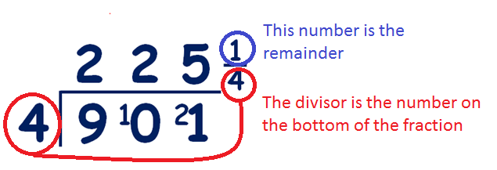  Questions:  946 ÷ 4, 6255 ÷ 6, 3484 ÷ 8, 1409 ÷ 4, 3172 ÷ 5 and 1059 ÷ 4.  Extension:  This should be completed in the maths book given. Answers can be found at the bottom of the page.  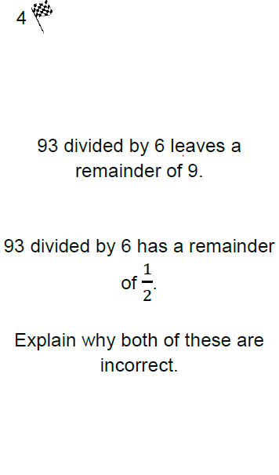
English | 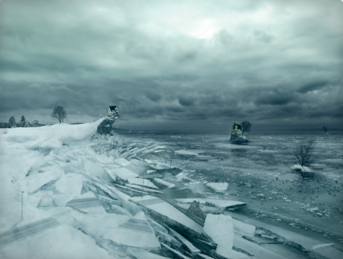  Story starter!  It was winter.  The thunder rumbling overhead seemed to taunt the young girl as she watched in horror while half of her home drifted away across the merciless, half-frozen sea.  She had awoken minutes earlier, disturbed from her sleep by the most appalling noise. It sounded as if a tree were being torn apart by giants, as if the Gods above were screaming at each other in a wild rage. She thought it was the end of the world. Perhaps it was. For her anyway.  In only her pyjamas, she stood on the edge of her ruined home, her toes dangling over the edge of the splintered floor, shivering in the harsh wind as it seemed to touch her skin like the kiss of some icy demon. She screamed at the top of her voice in despair and frustration, almost pleading with her frost-drenched surroundings to bring them back to her. She could see them. They were waving and shouting to her in return.  In front of her, she could see the giant, drifting shards of ice, their edges sharp like Samurai swords. They knocked into each other as they were swept by the tide, reminding her of some cruel jigsaw that couldn’t be solved. She knew she could not reach them…  Can you continue the story of the girl and her home that had broken in two? Who was it she was waving to?  What had caused the ice to break? Would she manage to reunite with the people drifting away?  When writing your story, consider your sentence starters. Use ISPACED to give you inspiration. You do not need to use all of them and they do not need to be in order. Not every sentence should start with one.  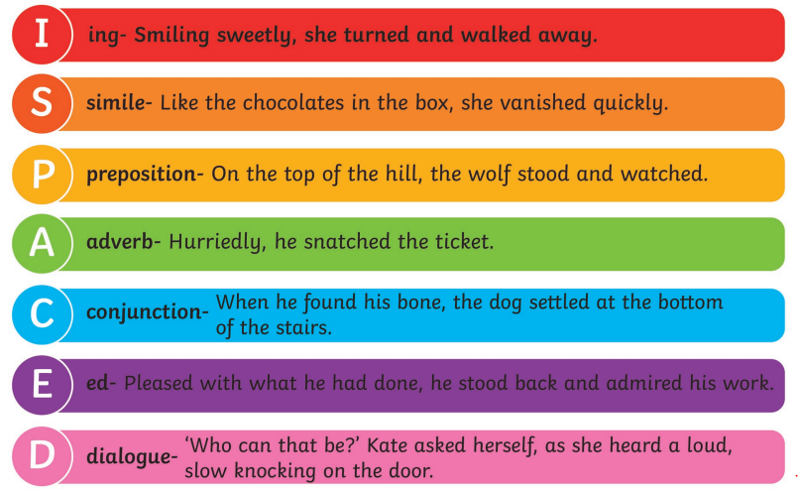  WALT- use a range of sentence starters.
Reading | Readtheory.org x 10  Read your own book for 20 minutes
Spelling | Spellingframe.co.uk- continue with spelling rule 53
Music | WALT- listen and appreciate music  Listen to the following music and complete the questions below.  Freilach by the Klezmer Festival Band https://www.youtube.com/watch?v=1u01MACxU-M  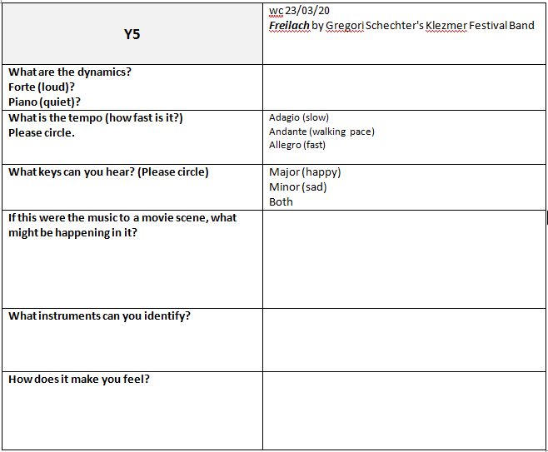
Science | WALT- compare the life cycles of different birds.  Read the following information:  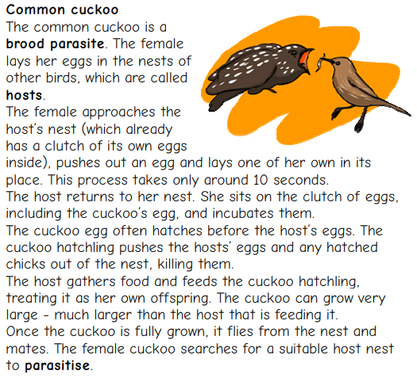  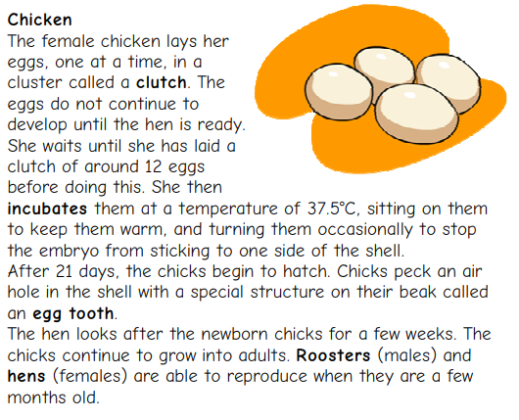  Draw and describe the life cycle of the birds. Use a format life below for each bird.  What do the life cycles have in common? How are they different?

