Year 5 Learning
Date: 25th March 2020
Maths | WALT- use short division for numbers up to 4 digits.  Parents note: In Year 5, short division is the main method we use, however, the children need the knowledge of the long division learning you have done on the past 2 days. Sometimes this method is called the bus stop method. The tutorial below explains this method and also discusses another key concept in division: it can be seen as sharing or grouping. Discuss this with your child. The questions for this learning will get progressively more difficult for the reason given in brackets.  Watch this online tutorial:  https://www.youtube.com/watch?v=lxg2eoNzFlA  Questions:  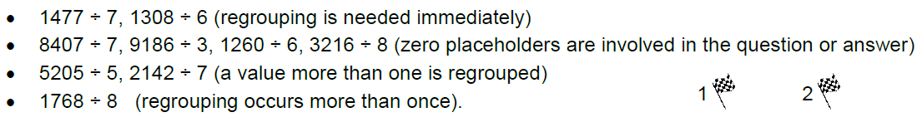  Extension:  This should be completed in the maths book given. Answers can be found at the bottom of the page.  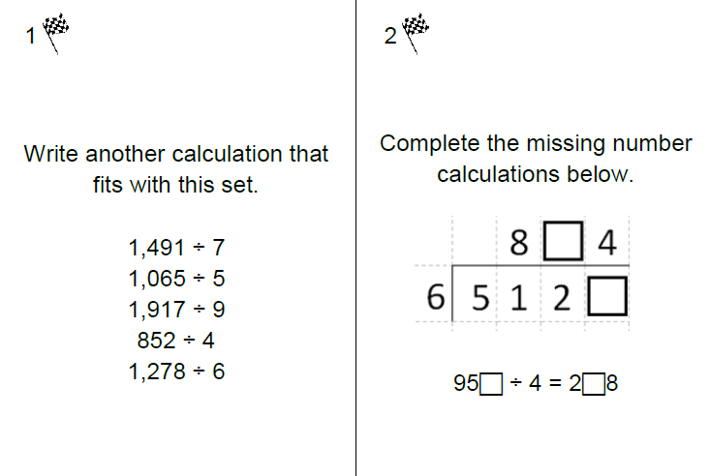
English | Story starter!  Some people love living dangerously. For some people, the thrill of a near miss is what they crave their whole lives; the moment of panic that rises up from the pit of your stomach like your blood has turned to ice, but then washes over you like blissfully warm water as the danger passes.  This was one of those moments. You could hear the sharp intake of breath as the crest of the fifty metre wave frothed and foamed like the mouth of an angry Kraken. There were only seconds left to wait...  Sentence challenge!  Write a paragraph to describe the wave. Include 2 relative clauses. If you have forgotten what relative clauses are, watch the BBC clip below.  https://www.youtube.com/watch?v=SYwiB5XD32M  Remember that you can embed the clause too: The door- which was bolted shut- was their only exit.  How else could I have punctuated this clause? Given the severity of the situation, dashes seem most appropriate, but not the only choice.  WALT- use relative clauses.  Parents note:  We have already covered relative clauses this year and so this should act as revision. The main error we see in class, is forgetting to punctuate the clause, when it is embedded.
Reading | Readtheory.org x 10  Read your own book for 20 minutes
Spelling | Spellingframe.co.uk  Parents note: This is a free site with no login details. Our current spelling list will be suspended for now. It would be a greate benefit for the children to learn the Year 5 and 6 spelling words. This week, every day, they should access thsi site to practice spelling rule 53.
French | Click this link to take you to our duolingo classroom.
Computing | Practice your coding.  Go to the scratch website and follow a tutorial or your choice.  https://scratch.mit.edu/ideas

