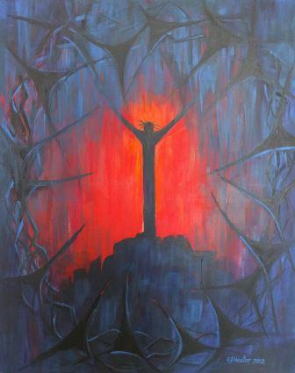

What Christian beliefs are represented?

What artistic choices has the artist made?

Write a prayer to accompany this art

What is happening?

What Scripture does this link to?