Year 5 Learning
Date: 1st April 2020
Maths | WALT- recognise and create equivalent fractions.  Parents note: We have now completed the division unit. On our fluency Fridays, we will always include a division calculation to consolidate our learning. Now we will move onto fractions. The Year 5 curriculum contains a lot of fractions so they will be the focus for a long time. If your child is unsure of fractions, they could watch this as a refresher of basic fractions: https://www.youtube.com/watch?v=FSTlQjxznUg  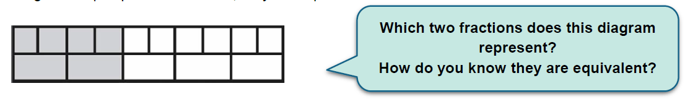  We can see that the first line is in 10 parts and 4 are shaded. This is a fraction of 4/10 . On the second line, we can see that is in 5 parts and 2 are shaded. This is a fraction of 2/5. The when the bars are placed side by side, it allows us to see that these fractions are equivalent (the same).  We can create equivalent fractions by looking at the relationship between the numbers.  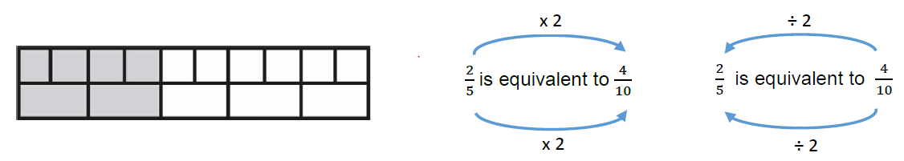  Watch the online tutorials:  https://www.youtube.com/watch?v=qcHHhd6HizI  https://www.youtube.com/watch?v=4xFwkDSMVw4  https://www.youtube.com/watch?v=mb1gyDw5LLo  Questions:  Log onto mathletics to complete the questions.  Extension:  This should be completed in the maths book given. Answers can be found at the bottom of the page.  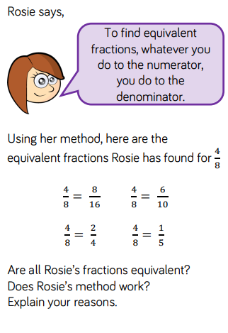
English | WALT- create a setting description  Today we will continue with writing based on the marshmallows animation:  https://www.youtube.com/watch?v=GwXFVqKuH-w  We are now going to go beyond what we see in the clip for our setting description. We are going to use our imagination and bring in our other senses such as smell. Watch/listen to the clip below to give you inspiration as to what might be there:  https://www.youtube.com/watch?v=Jb_4dE5VD_g  Complete your setting description. Use your sentences from yesterday and add in the additional details. Consider the order of the things that you will describe. You should start far away and get closer to that central location of the campfire to create a cohesive flow to your writing.  Things to remember in your writing today:  - Prepositional phrases.  - Figurative language. We thought about this last week.  - Extending your sentences with expanded noun phrases and additional clauses.  Here is an example description:  It was a clear, warm night. Crickets chirped in the distance, and intermittently an owl hooted. A solitary boat bobbed on the lake and from time-to-time the water slapped against it. Moonlight hit the ripples on the lake, reflecting little sparks of light like diamonds on the water. Far off in the distance, behind the lake, great mountains loomed. They looked like giant purple sleeping beasts. Tall trees with thick trunks edged the water and birds roosted in their tangled branches. A short leaf-littered pathway led to a camping area. In the middle of the camp, a fire crackled with red embers and ash rising upwards into the night sky. By the fire, a fallen log was used as a makeshift bench, and to the rear of the camp was a small canvas tent.  Parents note:  Editing is a big part of writing. When we edit in school, we read through looking for just one thing at a time. In today’s learning, the first read could check punctuation. The second could look at improving and adding adjectives. The third could focus on prepositional phrases etc.
Reading | Readtheory.org x 10  Read your own book for 20 minutes
Spelling | Spellingframe.co.uk- spelling rule 54
French | Log onto duolingo
Computing | Practice your coding.  Go to the scratch website and follow a tutorial or your choice.  https://scratch.mit.edu/ideas

